Name: Mriganka Patra
Emp ID: 2415820
Email: mriganka.patra@cognizant.com

Day 8 – Assignment 2

Objective: Understand Sales and Service Cloud features, build reports and dashboards, and configure security settings for data protection.

Tasks:
- Enable Sales Cloud and configure key features:
- Lead, Opportunity, and Contact Management
- Configure Sales Path or Sales Process
- Enable Service Cloud and set up and simple Case Management Process:
- Create Case Record Types and assignment rules
- Build 2 custom reports and combine them into a dashboard:
- Leads by Source
- Case by priority and Status
- Apply Salesforce Security Settings:
- Field-level security for sensitive fields (Ex: Revenue)
- Objects-level permissions for Service Agents
- Enable Login IP restrictions for added security
Deliverables:
- Screenshots/config steps for Sales & Service Cloud features
- Dashboard visual and reports
- Security configuration documentation

Task 1: Enable Sales Cloud and configure key features:
- Lead, Opportunity, and Contact Management
- Configure Sales Path or Sales Process

Sales Process :

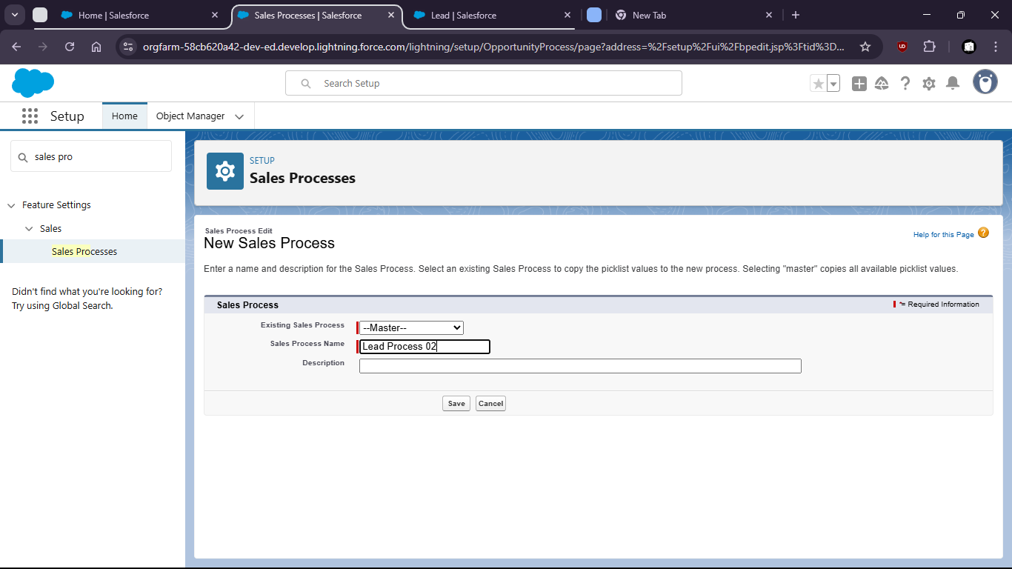

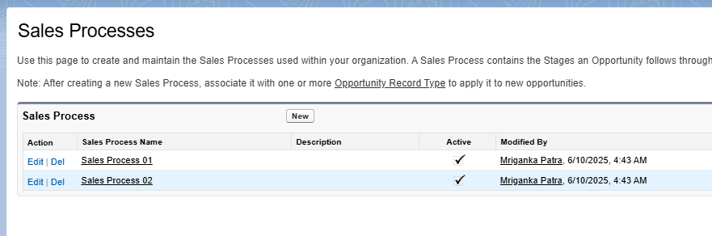

Lead Process:

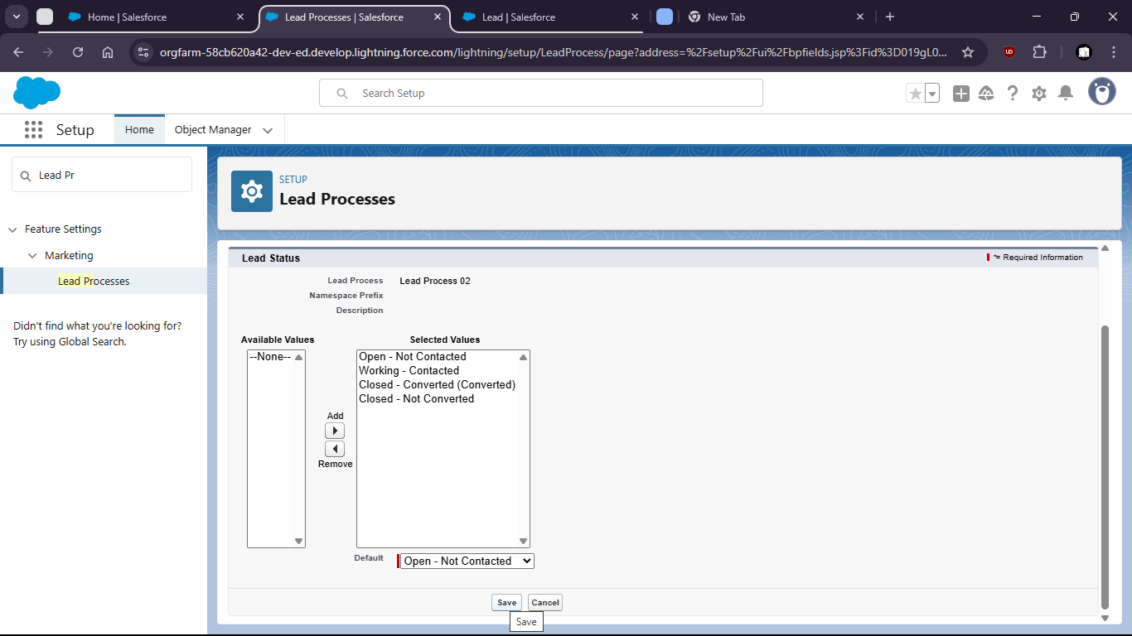
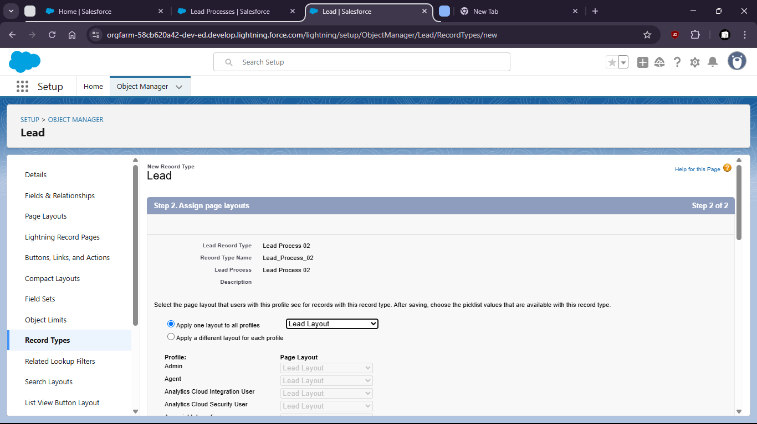

Oppurtunity:

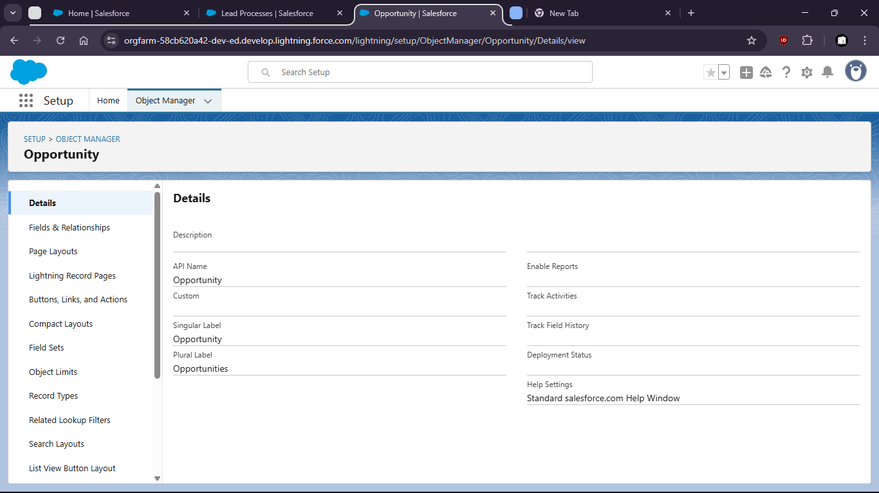

Contact:

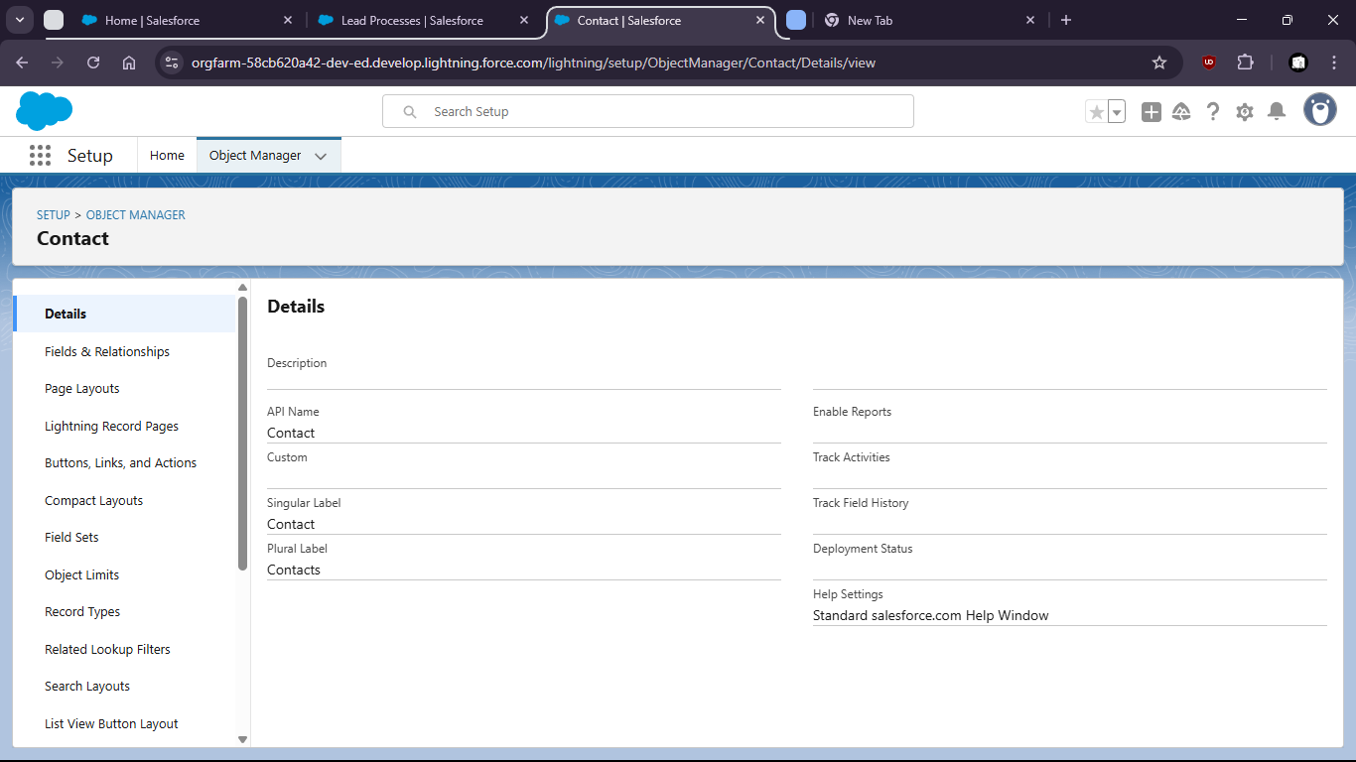
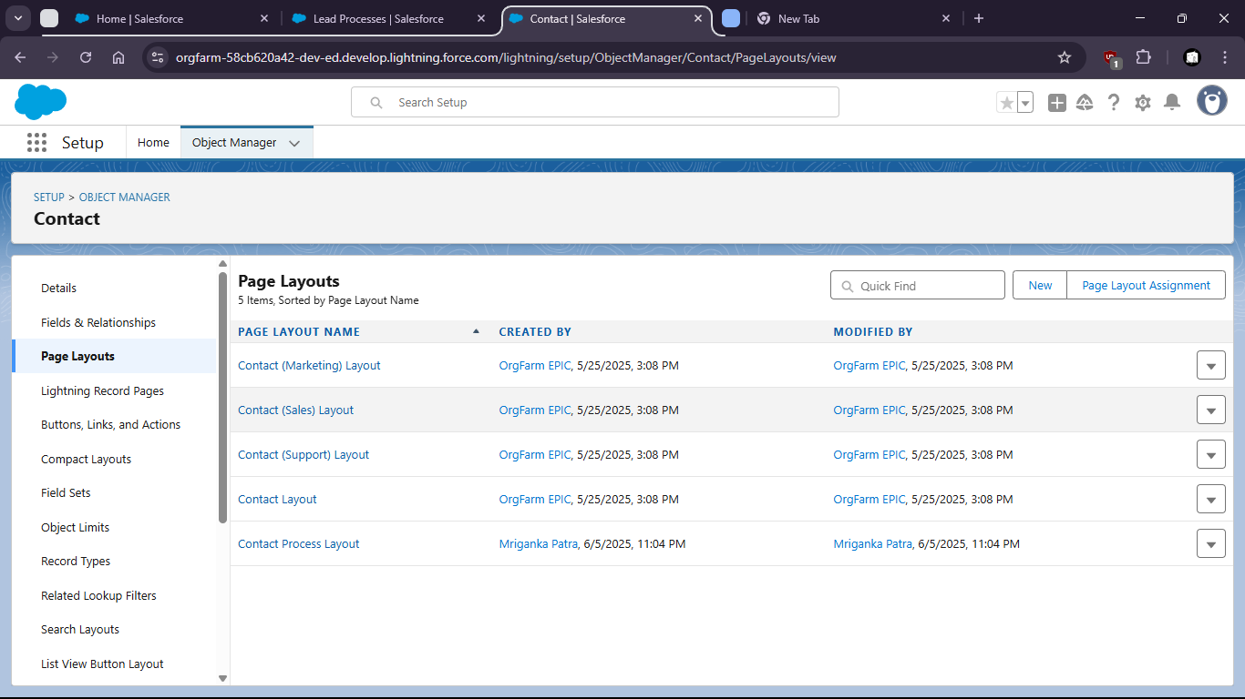

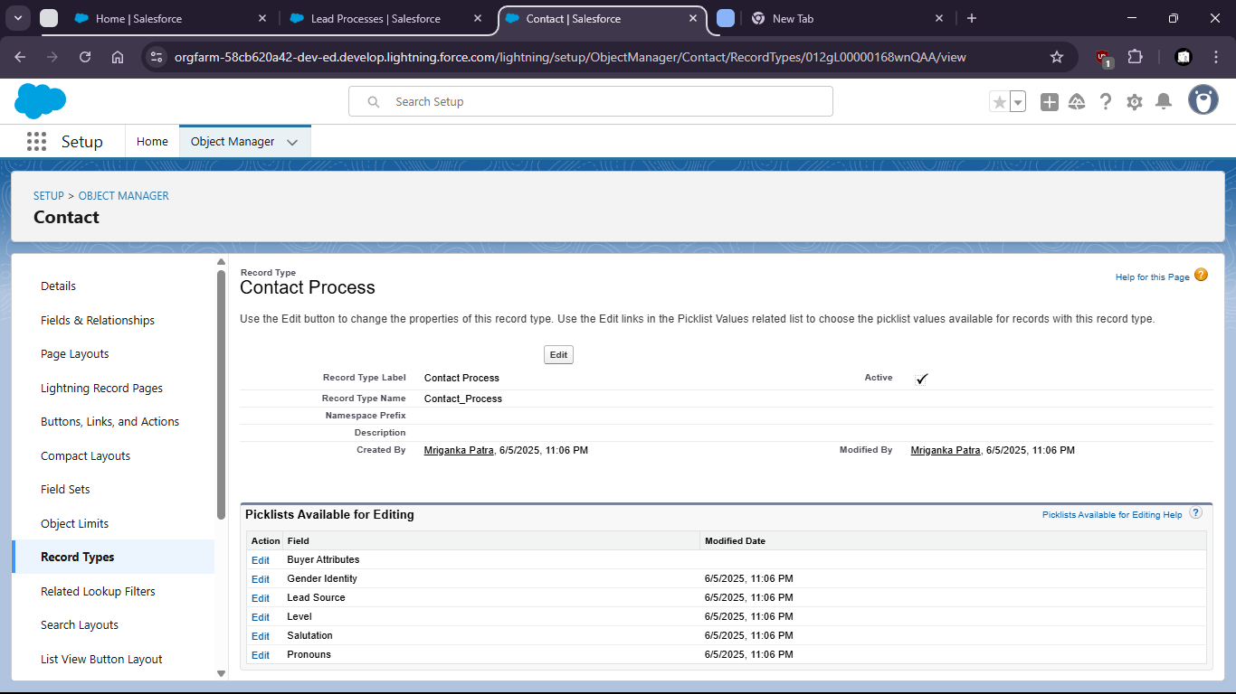

Task 2: Enable Service Cloud and set up and simple Case Management Process:
- Create Case Record Types and assignment rules

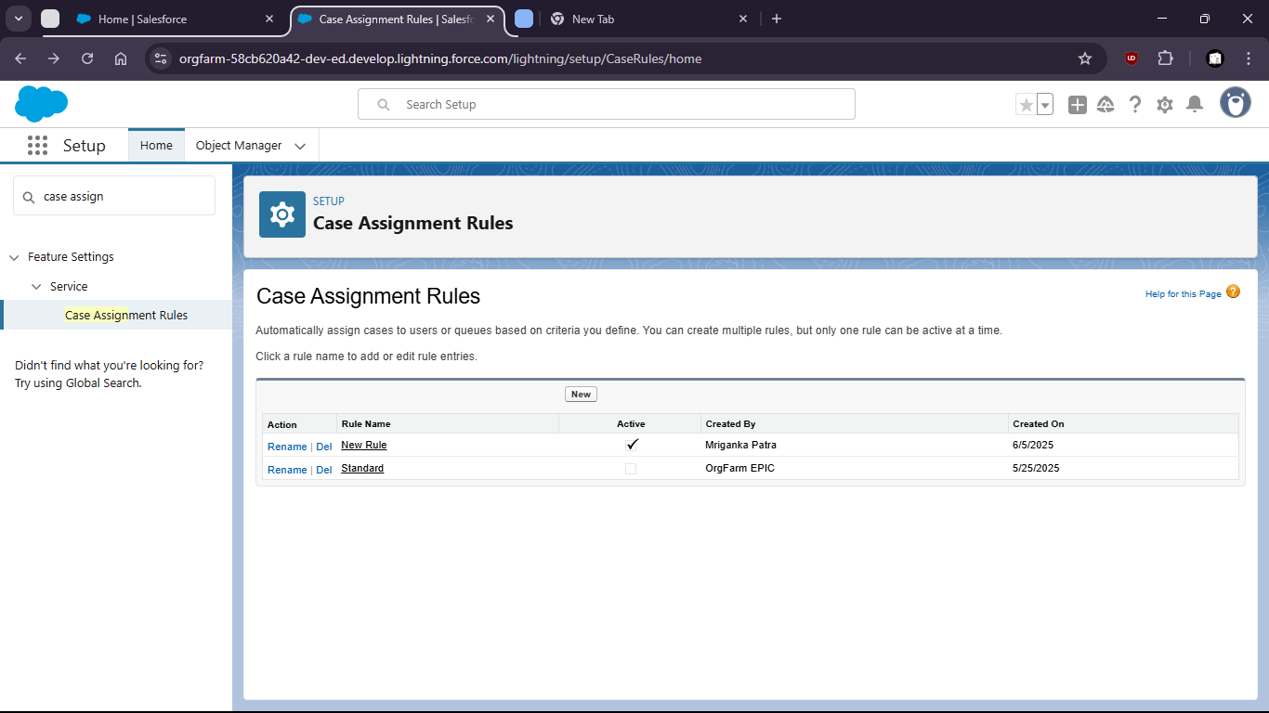

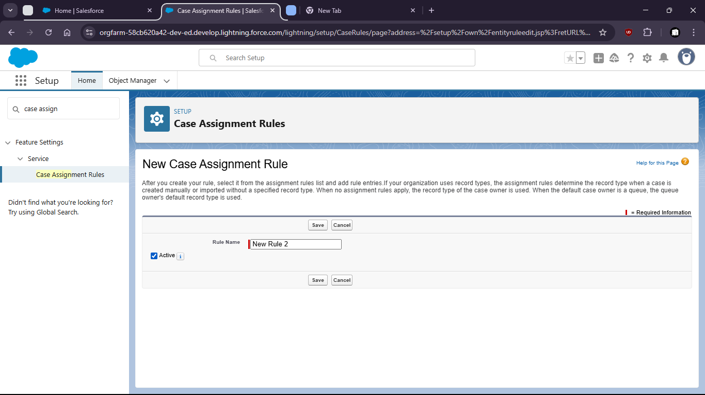

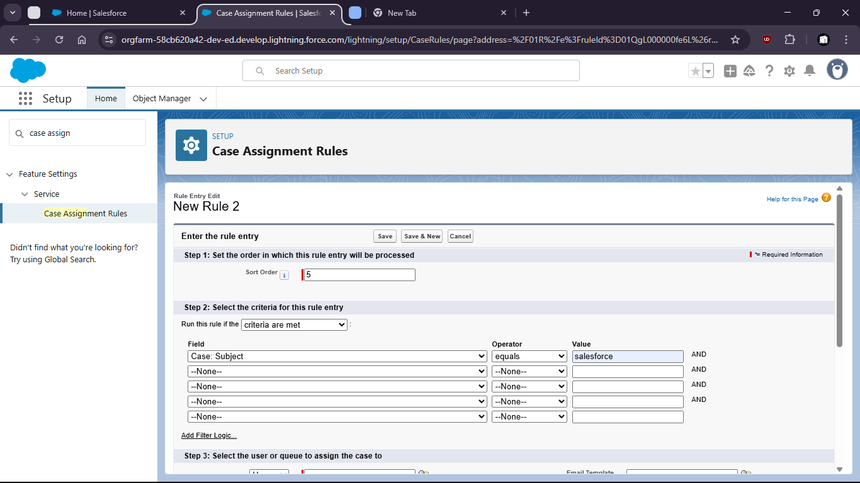

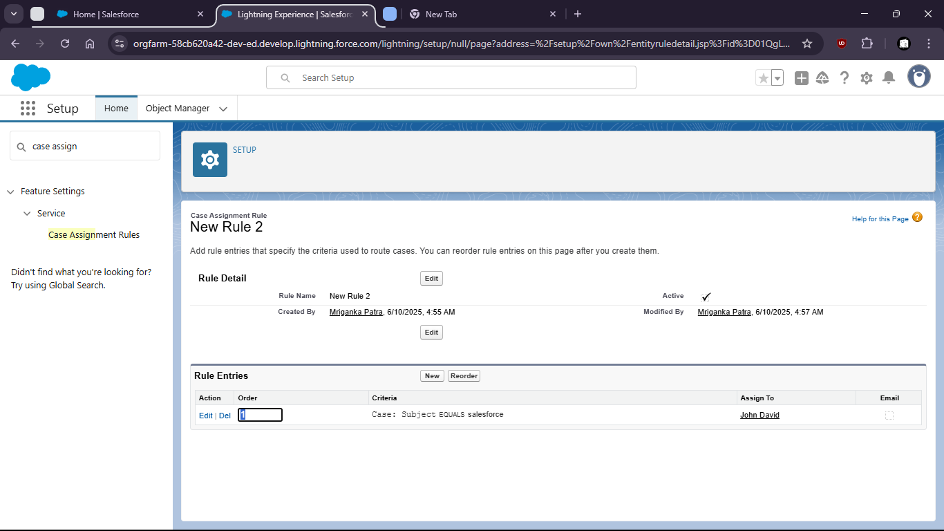

Task 3: Build 2 custom reports and combine them into a dashboard:
- Leads by Source
- Case by priority and Status

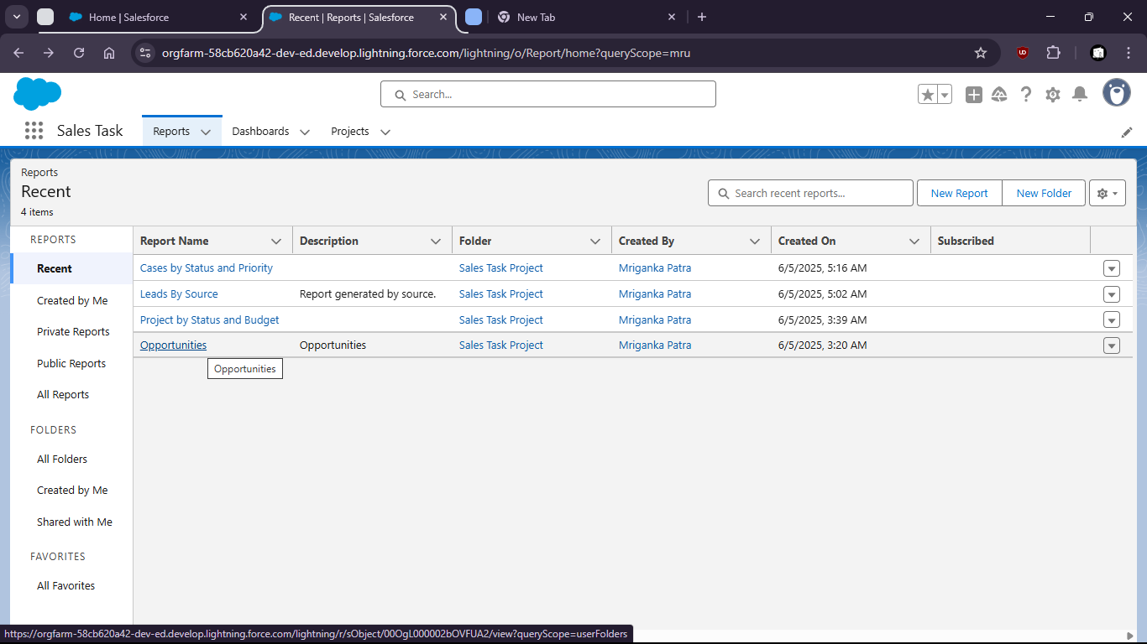

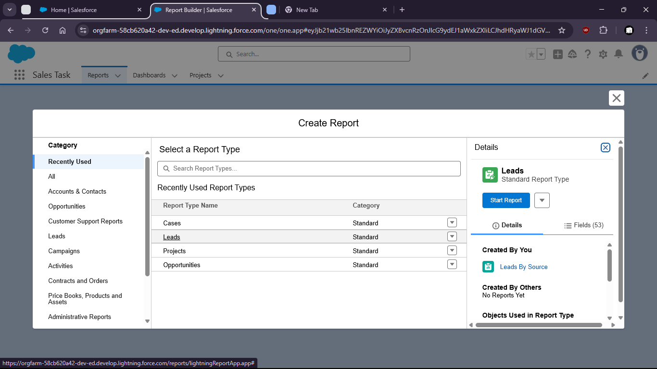

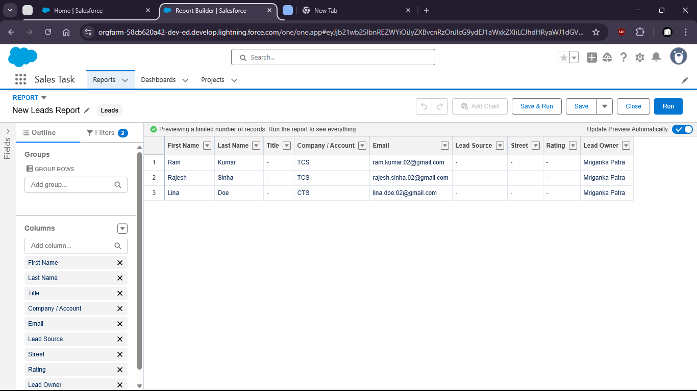

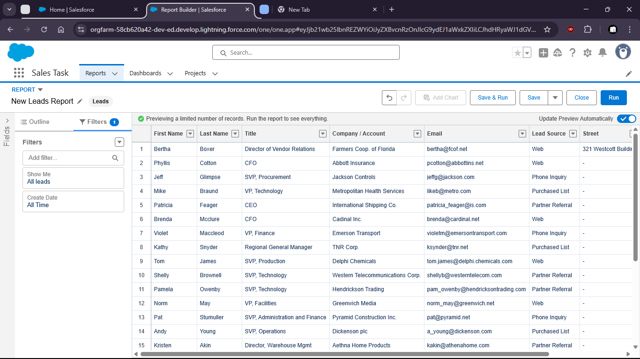

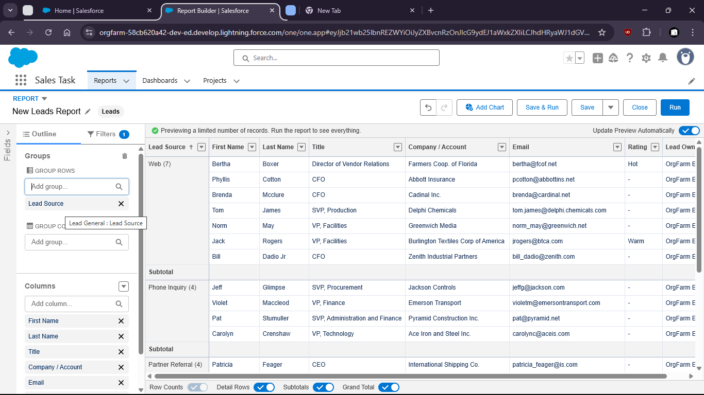

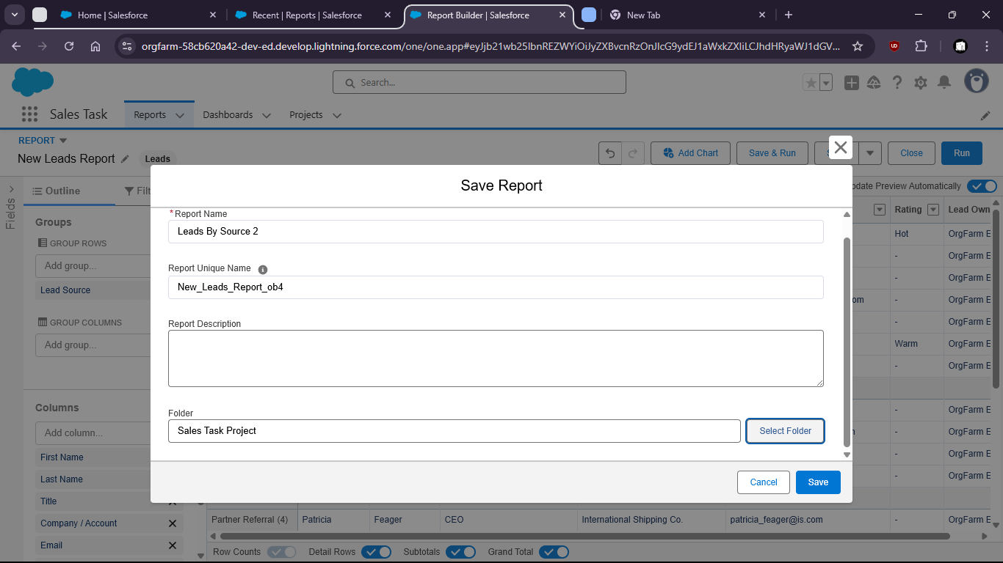

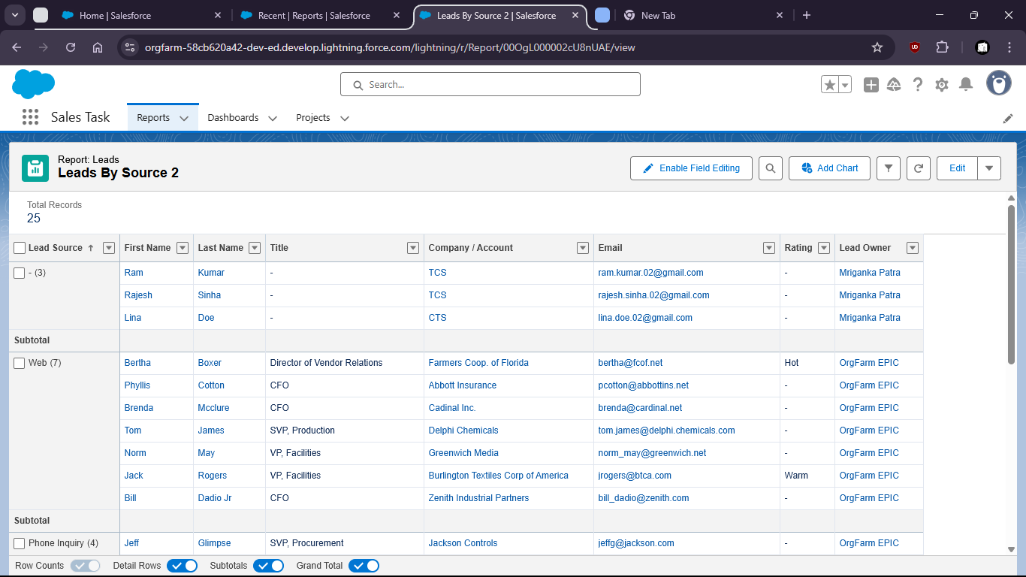

Cases By Priority and Status:

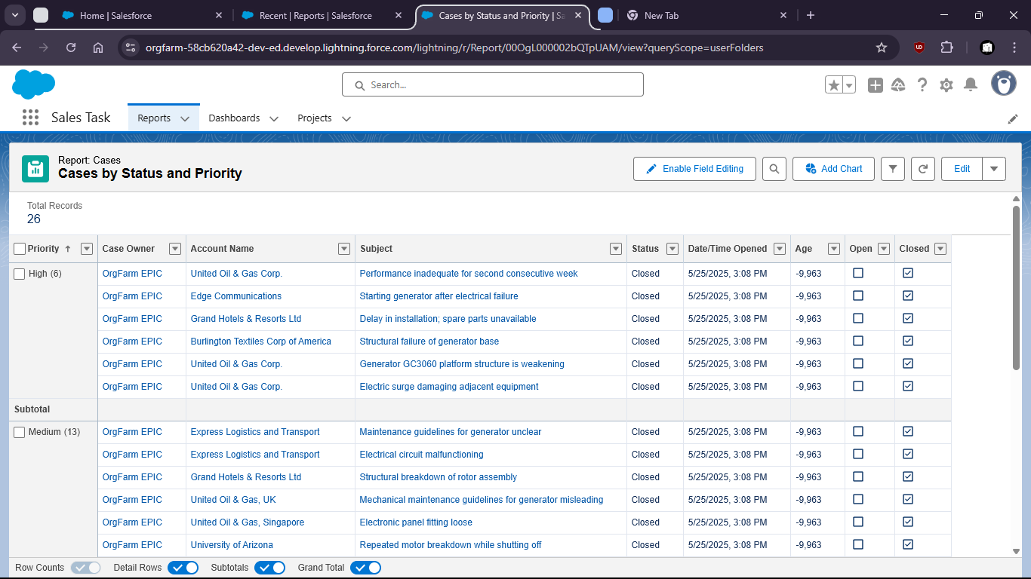

Dashboard View:

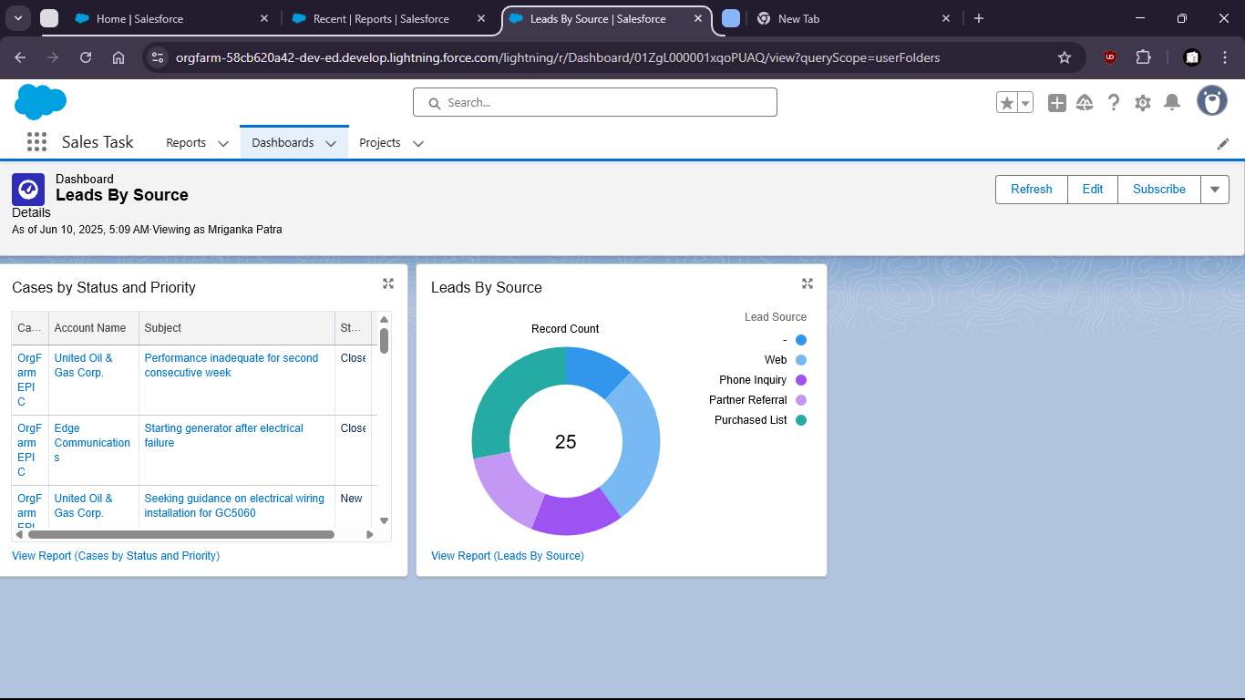

Task 4: Apply Salesforce Security Settings:
- Field-level security for sensitive fields (Ex: Revenue)

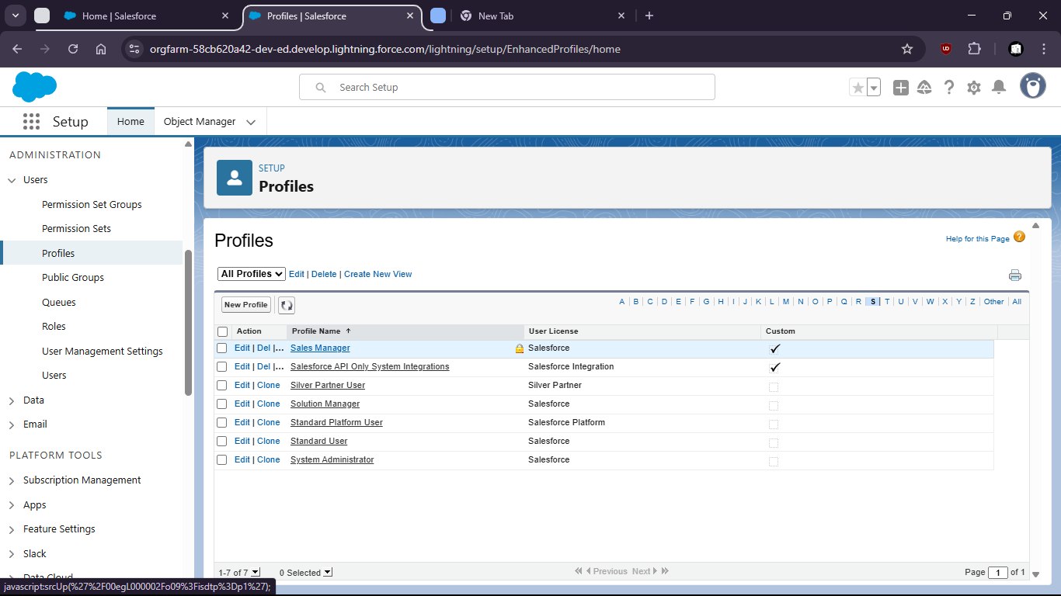

Field Level Security

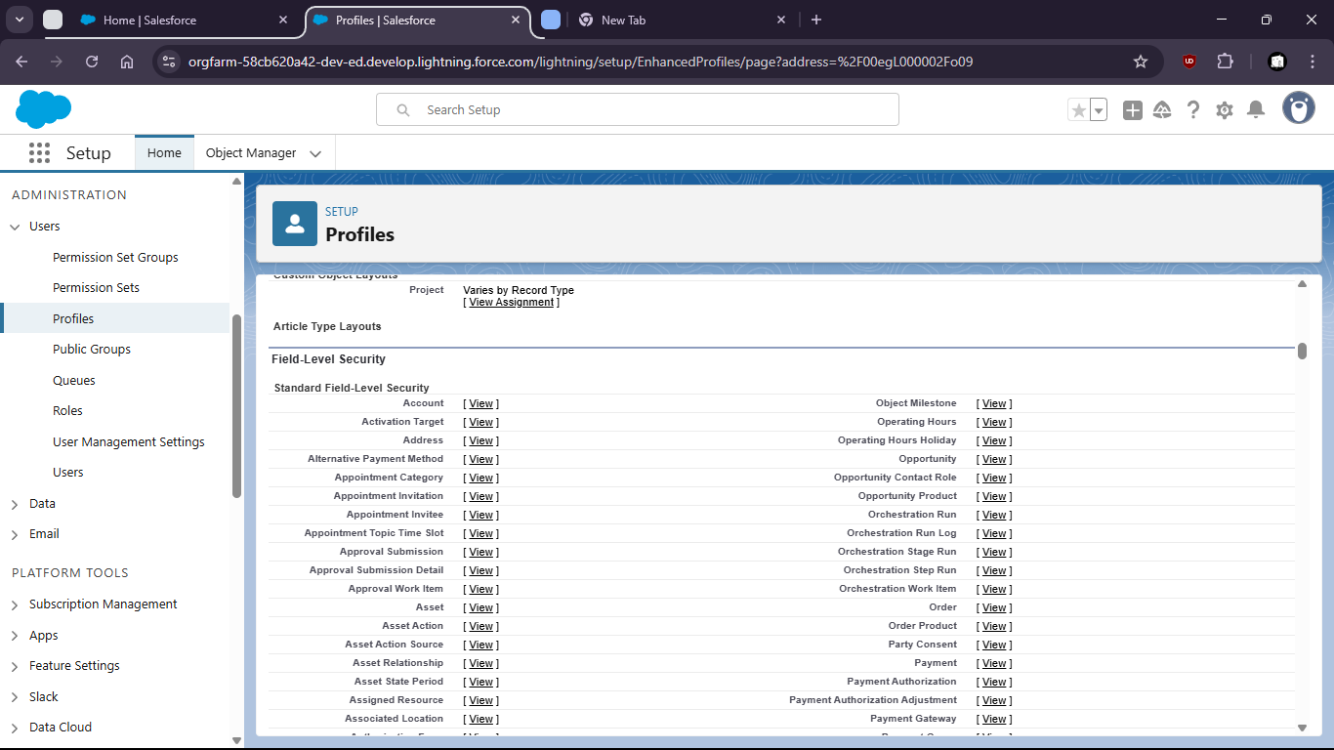

Under Account: Annual Revenue

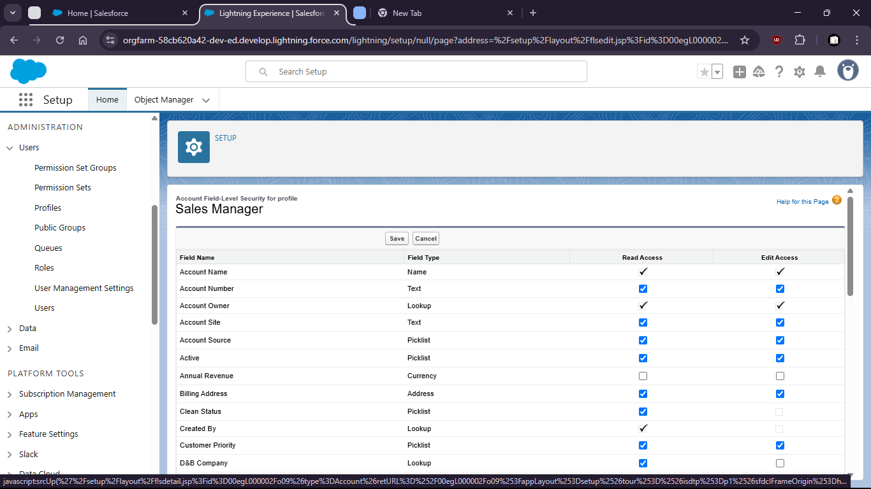

- Objects-level permissions for Service Agents

Standard object permissions

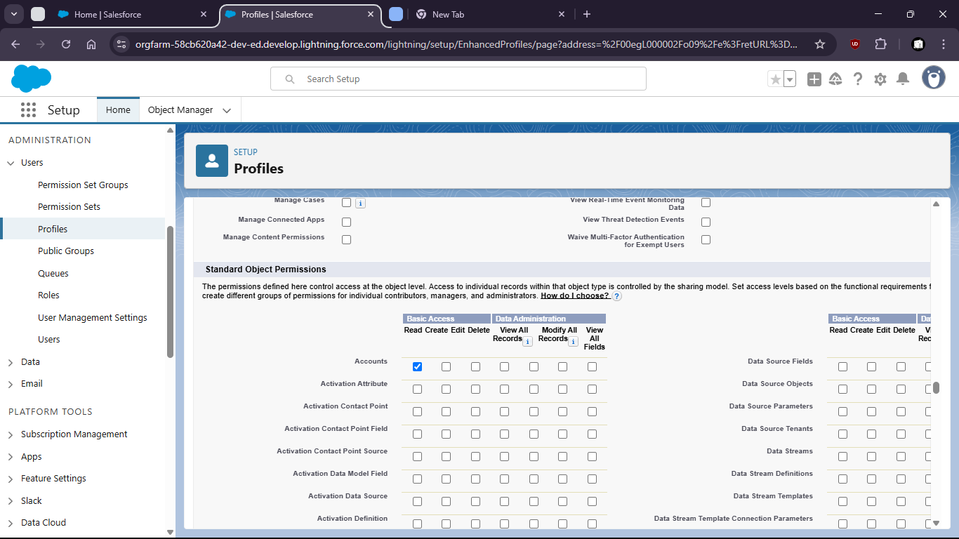

- Enable Login IP restrictions for added security

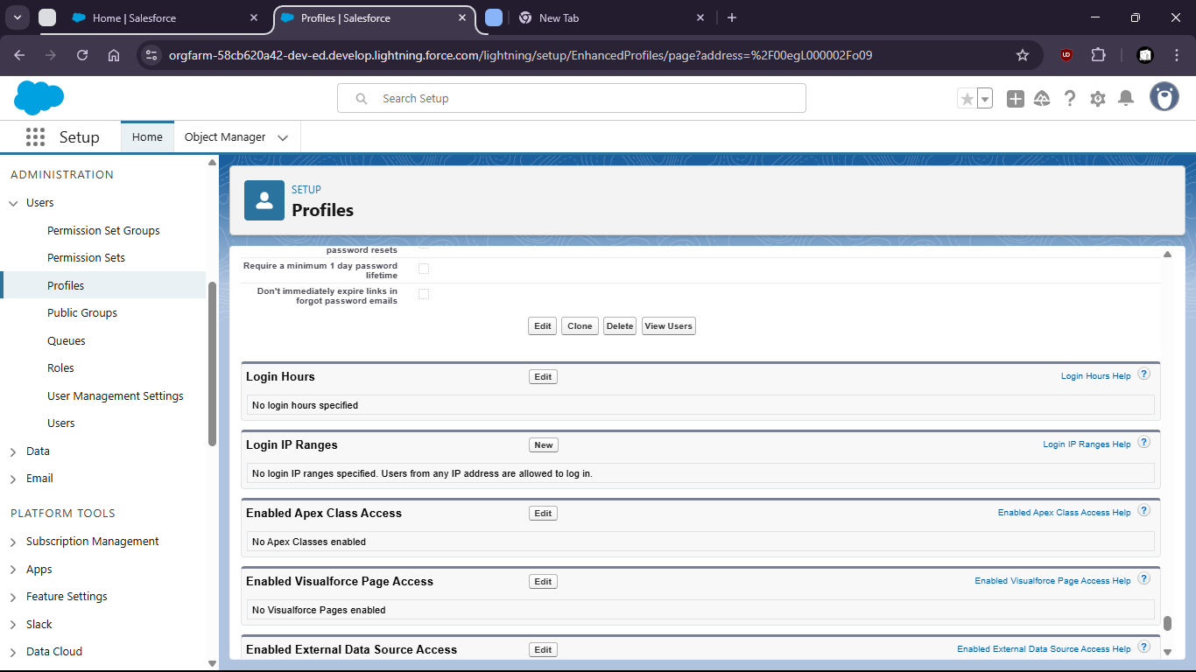

To get the ip:

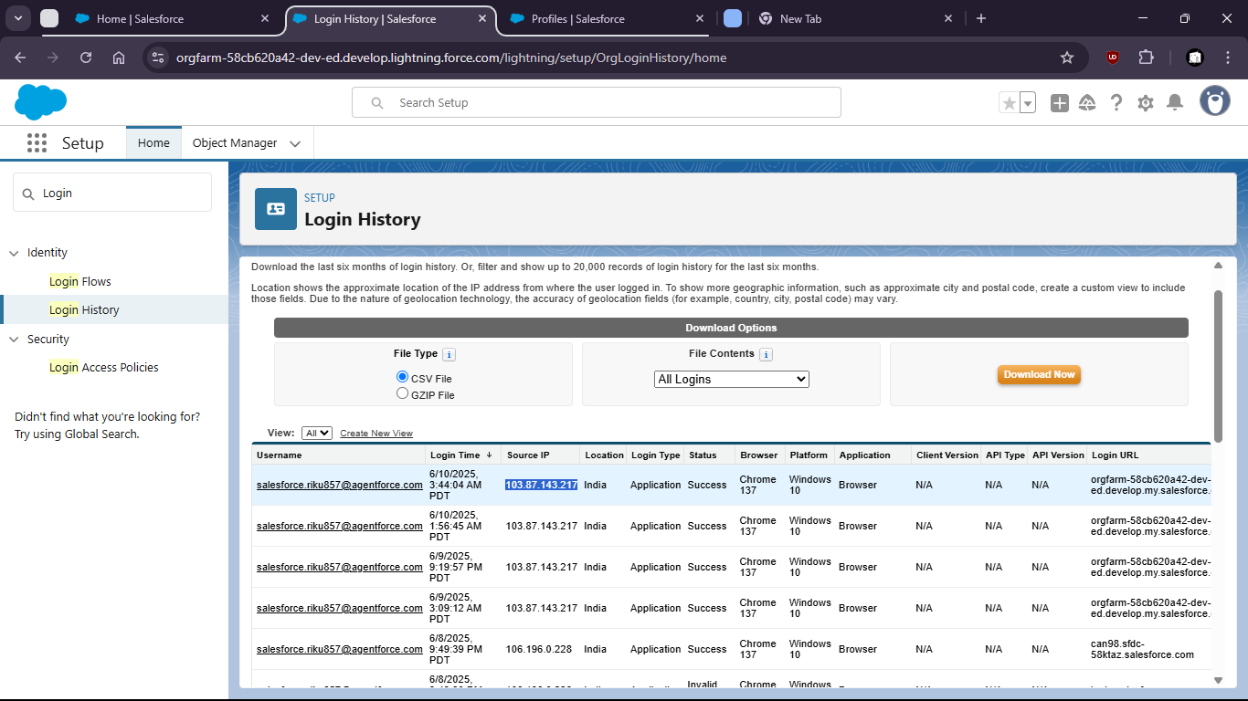

now set the ip:

